Lidcombe Public School
Annual Report

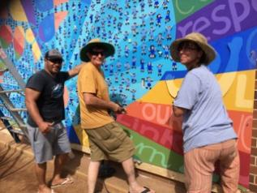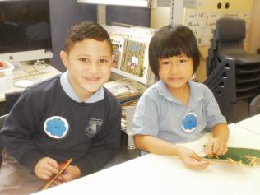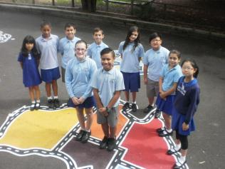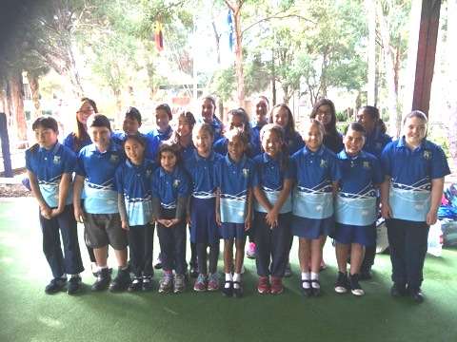
2015
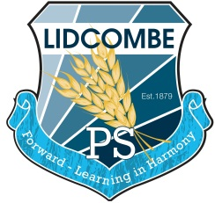
2394

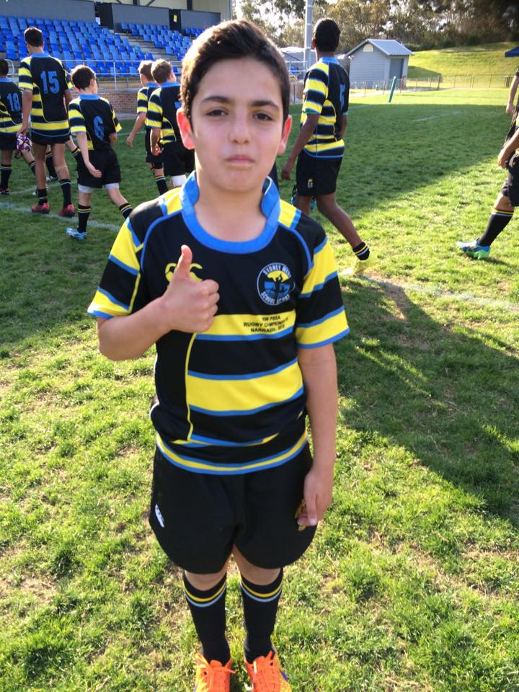
Introduction
The Annual Report for 2015 is provided to the community of Lidcombe Public School as an account of the school’s operations and achievements throughout the year.
It provides a detailed account of the progress the school has made to provide high quality educational opportunities for all students, as set out in the school plan. It outlines the findings from self-assessment that reflect the impact of key school strategies for improved learning and the benefit to all students from the expenditure of resources, including equity funding.
The Annual Report describes the school’s high quality practices across the three domains of the School Excellence Framework of learning, teaching and leading. For more information about the School Excellence Framework, please visit:
http://www.dec.nsw.gov.au/about-the-department/our-reforms/school-excellence-framework .
Matthew Lewis
Principal

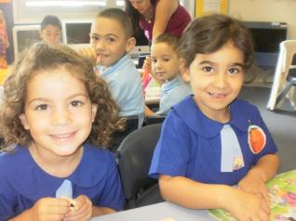
School contact details:
Lidcombe Public School
Mills Street, Lidcombe NSW 2141
Ph: 02 9649 7576
Fax: 02 9749 1197
Email: Lidcombe-p.school@det.nsw.edu.au
Web: www.lidcombe-p.schools.nsw.edu.au
School Code: 2394

Message from the Principal
It is with great pleasure that I present the 2015 Annual School Report for Lidcombe Public School.

The core business of our school is highlighted through our motto, Forward - Learning in Harmony. Through explicit and systematic quality teaching in literacy, numeracy and across all key learning areas our teachers guide, challenge and extend our students in the development of the foundation skills they will need for continued learning in the 21st century. Our school vision statement, developed through community consultation in 2014, highlights a vision where the school will focus on the teaching and learning of skills that will allow students to use those foundation skills in conjunction with future focused key competencies such as creativity, collaboration, critical thinking and communication.

As principal of this school I am very proud that our school continues to have a great reputation within and beyond of our community at Lidcombe. From feedback we received as part of the vision process in 2015 some of the reasons for this include:

- Students are our primary focus
- We aim to support all students to reach their potential
- We promote a culture of striving for your personal best
- Our staff are caring, motivated, professional and hard working
- As a team, the staff provide a range of additional learning experiences and opportunities
- Parents are partners in the schooling process and they contribute significantly to our school
- We are continually working to build connections with our local community
- We value and are proud of our school and local environment
- We celebrate the achievements of our students
- We teach values and promote resilience

This report highlights our achievements over the past year and targets specific areas for further development. I certify that the information in this report is the result of a rigorous school self evaluation process and is a balanced and genuine account of the school’s achievements and areas for development.

Matthew Lewis
Principal

Message from the School Captains 2015
When we first came here in Kindergarten we never believed that we would get so far. Lidcombe Public School has so many programs that have helped us come out of our shells, gain confidence to be enable us to be where we are today.

Our school leadership team has been to many places and we have learnt so much. We have been to a leadership conference where we learnt how to be ‘positive and capable’ leaders.
The majority of Stage 3, being the leaders of the school, went to Berry Sport and Recreation Camp in 2014 where we had a great time learning many useful skills such as teamwork and communication. We also went to Canberra this year where we learnt all about our nation’s capital. These overnight excursions have taught us resilience, how to look after ourselves and how to get along with one another outside of school.

In SRC meetings we always tried to make the school a better environment to play in and enjoy. Some examples of things we helped improve are the handball courts and tiger turf on the Stage 1 soccer field.
With the great warm hearted school community, together we have achieved even more programs such as playground activities and the new award system.

The school has taught us that we can always reach our goals if we try our best at all times. As captains we have learnt many things and been given many opportunities. Thank you to all the teachers who have taught us all we know. Thank you to the support and office staff for all you do for us. Thank you also to all the students who make every day at Lidcombe Public School such a joy. We hope everyone can continue to learn and thrive together.

Kapeliele Fusi and Sarah Steel
School Captains

School background
School vision statement
Lidcombe Public School is an inclusive community providing innovative, quality programs and a relentless focus on academic success, which respects and caters for individual needs in a safe and happy environment.
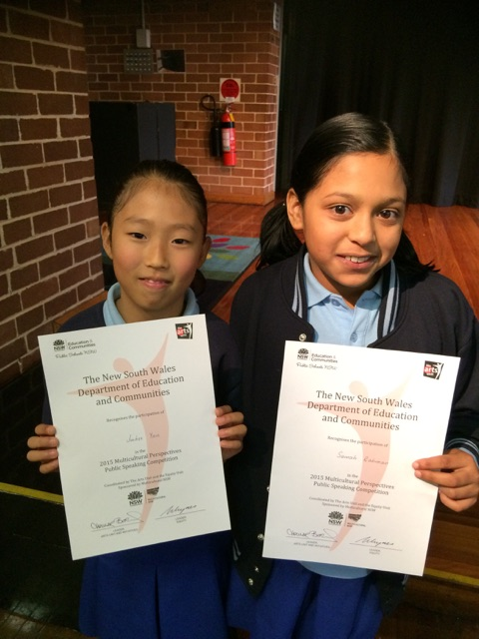
Lidcombe Public School is committed to the pursuit of excellence and the provision of high quality educational opportunities for every child and adult at our school. Staff join with the school community in making a strong collective commitment to nurture, guide, inspire and challenge students – to find the joy in learning, to build their skills and understanding, and to make sense of the their world.
In the early years, it means having confidence that each individual child will be known and understood, and their individual potential developed. As student’s progress, it means knowing that they are well supported as increasingly self motivated learners – confident and creative individuals, with the personal resources to equip them for future success and wellbeing.
As a school community, our collective goal is to provide a rich educational environment that supports the consistent improvement of student outcomes and the narrowing of achievement gaps between students. This means that staff and parents are committed to ensuring that students achieve at least a year’s worth of learning from every year of schooling and teaching.

School context
The school has a strong reputation for its commitment to learning and its strength in providing welfare programs including PBL to increase the likelihood that learning will occur. The school community is highly multilingual (92% LBOTE) with at least 44 different languages being represented. The most predominant languages (March 2014) are: Chinese (22%); Korean (14%); Arabic (11%); Turkish (11%); English (7%); and Vietnamese (5%).

The school comprised of 25 mainstream classes and 3 special education classes. Specialist programs include Reading Recovery, Leaning and Support, English as an Additional Language/Dialect, and Community Languages in Chinese, Korean, Turkish and Arabic.

The school prides itself on forging strong links with the local community and has a growing, highly committed P & C Association whose members are actively involved in consultative decision-making inclusive of fulfilling staff vacancies through the Merit Selection process, school self-evaluation processes, broad financial management decisions, decisions relating to capital improvements and school policy decisions.

Lidcombe Public School’s enrolment has been steadily increasing over the past five years with a current enrolment (December 2015) of 665 students.

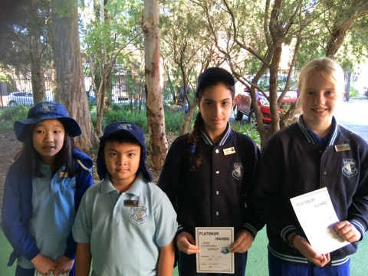

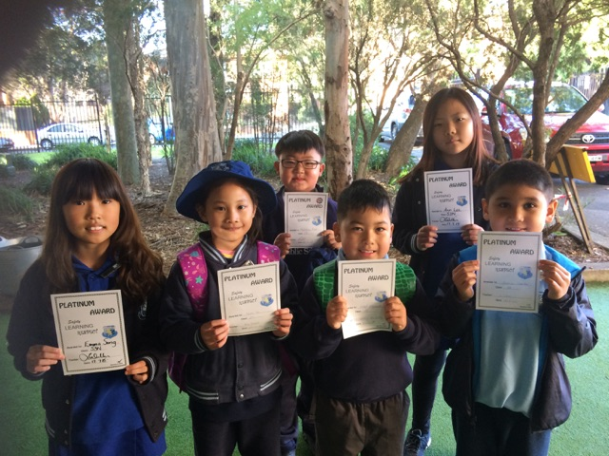
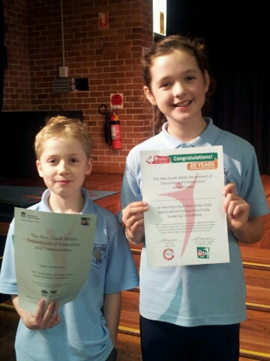

Self-assessment and school achievements

Self-assessment using the School Excellence Framework
This section of the Annual Report outlines the findings from self-assessment using the School Excellence Framework, our school achievements and the next steps to be pursued. The Framework supports public schools throughout NSW in the pursuit of excellence by providing a clear description of high quality practice across the three domains of Learning, Teaching and Leading.
This year, our school undertook self-assessment using the elements of the School Excellence Framework and its implications for informing, monitoring and validating our journey of excellence. The 2015 school plan projects addressed all School Excellence Framework elements.

Our self-assessment process will further assist the school to refine the strategic priorities in our School plan leading to further improvements in the delivery of education to our students. In the domain of Learning, our focus areas have been Learning Culture, Curriculum and Learning, and Assessment. The development and implementation of evidence-based learning and innovative delivery has been fundamental to our progress. All learning teams identified areas for improvement, using student data, including PLAN, L3, TENS and NAPLAN. This data is shared and analysed in 5 week cycles and determines resources to support areas of need. Stage 1 undertook L3 training to capitalise on the Literacy growth evidenced in the early stage 1 L3 program to provide greater impact on student success. Students 3-6 engaged in problem based learning and reflected on the skills developed and learning processes. Teachers reflect on student data with colleagues to measure their own professional learning, and this directly relates to accreditation evidence and performance and development goals achievement. With the community of schools (RALBY) all teachers undertook extensive professional learning about the History K-10 syllabus and began teaching from the Science K-10 syllabus. Through surveys and discussion groups it was evident that student thinking changed from education being about learning facts and preparing for tests to education being about thinking critically and creatively about things that interest you. The collective responsibility for 21st century learning and success also increased. The school aims to continue developing this culture with a strong focus on wellbeing in 2016.
Our major focus areas in the domain of Teaching have been Professional Standards and Learning and Development.
Teachers demonstrated their commitment to their ongoing development and actively planned their own professional development to improve their performance.
Professional Development Plans (PDPs) were aligned with the Professional Standards. The growing of teaching practice through coaching and mentoring (or Action Learning), classroom observations, reflection and feedback highlight a teaching culture focused on improved individual performance. Staff are working towards the development of expertise in 21st century learning skills in line with new syllabi and through Future Focused Learning in 2016, aim to further improve on this practice.
In the domain of Leading, our priority has been on Leadership as we recognise that instructional leadership is central to school leadership capacity building and the achievement of school excellence. Aspiring leaders engaged in coaching and mentoring sessions in learning teams, professional learning committees and/or lead whole school or RALBY staff professional learning sessions, ensuring effective implementation of key initiatives across the school. The leadership team has been successful in leading initiatives outlined in this report, building the capacities of all staff to create a dynamic school learning culture. Leaders facilitated and connected with networks to build upon leadership skills within the school.
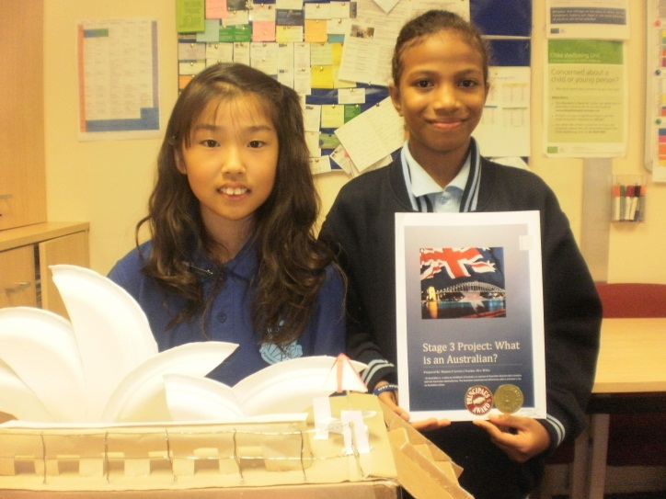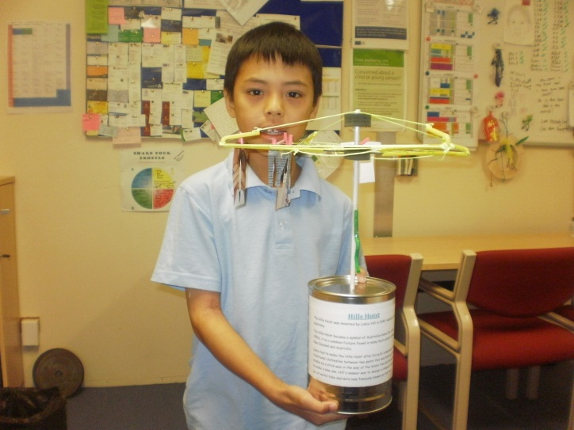
Strategic Direction 1
Student Learning - Students will be empowered, innovative, humane citizens who value and contribute to our world.

Purpose
We want our students to be confident, happy, active citizens in a globally connected society. Our students need to love learning. They need to be forward thinking, inquisitive, independent and creative learners who embrace continual change with confidence. They need to communicate effectively, collaborate with others, be imaginative and develop their skills to successfully drive their own learning.
Overall summary of progress
Staff reflected on 2014 student data and identified areas for improvement in learning teams, as evidenced in developed learning sequences in teaching and learning programs, teachers performance and development plans and school data (inclusive of L3, TENS, PLAN, and NAPLAN).
L3 (Stage 1) was successfully implemented with the support of two trainers, as evidenced by student Literacy growth. One staff member achieved accreditation as an L3 trainer (Stage 1) and will be based at the school in 2015 to provide ongoing professional learning to school staff.
Teachers are implementing rich, authentic Science tasks as part of their Science programs, following successful implementation during 2014 and 2015. A two year stage planning sequence of thematic units was developed to implement the new Science and History syllabi (K-6).
All students identified for the Nationally Consistent Collection of Data for Students with a Disability (NCCD) survey were already identified by the Learning Support Team and receive differentiated learning through quality teaching and/or other adjustments. Parents and non-DoE professionals are invited to participate in the planning and review process for students requiring individualised learning and support.
Progress towards achieving improvement measures |  | Resources (annual)
Improvement measure  (to be achieved over 3 years) | Progress achieved this year | <$>
Sustained student growth in NAPLAN data. | Please refer to the NAPLAN section in this report. | $0
Sustained student growth in school based assessments for K-6. | School data (inclusive of PLAN, L3 and TENS) showed sustained growth across the curriculum (K-6) | $1500 (TPL)  $2000 (Resources)
Planned, targeted learning support for all students. | The Learning Support Team ensured that planned, targeted learning support was offered for all students listed in the 2015 NCCD survey. | $0
Collegial analysis of student data and assessments. | Teachers continue to reflect on their teaching and their students’ learning. They are developing and applying a comprehensive range of assessment strategies to support the learning needs of all learners, supported by L3 and TENS (K-2) and PLAN (K-6) every 5 weeks. | $0
Increased staff expertise in a variety of assessing methods and Action Learning cycles. | Collegial analysis of student data and assessments is led by the executive team throughout the school. | $0
Next steps
Even though school based L3 and TENs data showed increased growth for K-2 students during 2016, the 2015 AEDC data report showed that the number of students entering Kindergarten in the ‘At Risk’ and ‘Vulnerable’ categories has significantly increased since 2009 for language and cognitive skills (13%), and communication skills and general knowledge (14%). To meet the changing needs of students in the Lidcombe area, the following strategies have been identified:
- Staff professional learning about learning centres for all students, and individual research type projects for gifted and talented students to increase the number of students achieving higher syllabus outcomes;
- Whole school sharing of L3 and TENS strategies and professional learning in PLAN and Critical Aspects continuums K-6, 21st century learning and critical and creative learning;
- Ensuring continuity of best practice Literacy and Numeracy from K-2 L3 and TEN into Stage 2 linking back to the Literacy and Numeracy continuums.
- Staff professional learning and resourcing for more effective teaching and learning in music and creative arts;
- Surveying of students, staff and parents to analyse the effectiveness of new syllabus document implementation;
- Refining the Science and History sequence planning by each stage in 2015 with an emphasis on using a thematic approach to include Geography syllabus outcomes;
- Reviewing the organisation of the school’s LaST resource and Teaching and Learning Programs policy in line with the school Learning Support Policy, “Every Student Every School,” 21st Century learning and the School Excellence Framework to enhance school’s effectiveness in supporting all teachers to further the impact of individualised supports and adjustments for all students;
- Determining directions for further individualised learning in 2016/17 for all students and hold handover meetings with 2017 teachers for all students with individualised support; and
- Participating in the “Tell Them from Me” surveys to learn more about the needs of our students, staff and community and gain external feedback on our success.

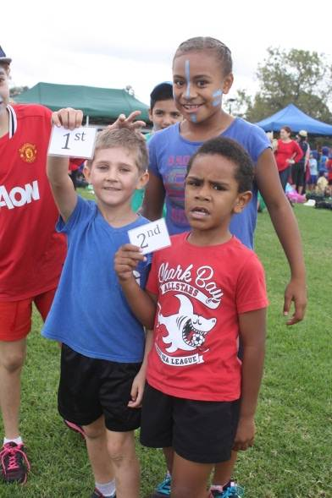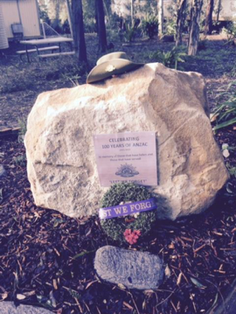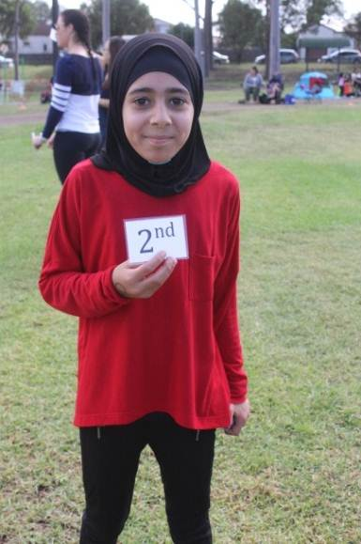
Strategic Direction 2
Staff Learning - Staff will actively embrace a dynamic, collaborative and informed professional culture.

Purpose
Research shows that the greatest effect on student learning is increased teacher leadership capacity in the classroom, supported by explicit instructional leadership throughout the school, underpinned by professional dialogue about student data and the Australian Professional Teaching Standards. Teachers need to be passionate about activating visible learning for their students and for themselves. To create the best supportive learning environment for their students, all staff need to be inspired to learn with each other and the community, and understand different learning styles to cater for all students.
Overall summary of progress
All teaching staff completed professional development plans, and reflected on student learning data as part of mentoring and coaching with their team leaders and/or colleagues.
All early career teachers are aware of the accreditation process and are successfully gathering evidence for maintenance and/or achievement at proficiency level. Two early career teachers successfully completed their accreditation and four temporary teachers were successful in gaining permanent positions.
A coherent professional learning focus for 2016 has been determined and included in planning, as a result of collaborative reflection and community feedback, inclusive of a staff survey.

As a result of the community of schools (RALBY) professional learning focus during Term 3 and Term 4, all teachers are able to fully implement the Science K-10 and History K-10 syllabi in 2016.
In a staff survey focusing on professional learning, all respondents stated that staff meetings and professional learning time is used effectively in the school. 100% respondents also stated that they were supported by the executive and that they supported the executive in leading the school. L3, Reading Recovery, TENs, sport and performing arts programs were identified by the staff as having the greatest impact on teaching and student learning in 2015.
Progress towards achieving improvement measures |  | Resources (annual)
Improvement measure  (to be achieved over 3 years) | Progress achieved this year | <$>
Data informed, differentiated and personalised learning experiences are highly visible in all teaching and learning programs. | Data informed, differentiated and personalised learning experiences are highly visible in all staff teaching and learning programs. | $0
All staff have individual professional learning plans that demonstrate reflective teaching practice, are linked to the Australian professional teaching standards and guides their learning, practice and capacity to improve student learning. | All staff identified personal and professional learning goals in their Performance and Development Plans, demonstrating reflective teaching practice and guided their professional learning, practice and capacity to improve student learning. | $35000 approx (TPL)
Next steps
Lidcombe has proactive staff members who clearly understand and utilise assessment for learning, assessment as learning, and assessment of learning in determining teaching directions, school performance levels and effectiveness. As a result of school data reflection, staff learning for 2016 will include the following steps:
- Accreditation and maintenance of accreditation made visible for all teachers by linking the Australian Professional Standards for Teachers with teachers’ performance and development plans and all professional learning activities;
- Identified teacher professional learning in: L3 (Stage 1 OPL), TENS, PLAN, Literacy and Numeracy Critical Aspects Continuums; Future Focused 21st Century Inquiry based learning provides a greater impact on teaching and learning; and continued implementation of procedures using LMBR to support student management;
- Mandatory whole staff learning (WHS, Child Protection, Anaphylaxis, Emergency Care, extremist behaviour);
- PBL refresher training for PBL leadership team members to review the school’s PBL procedures, including playgrounds, restitution and effective data sharing and analysis;
- Review of the school’s Teaching and Learning Policy in line with new reforms in response to the Melbourne Declaration to ensure that Future focused 21st Century and inquiry based learning will be evidenced in all performance and development plans; and
- Developing modules for English and Maths syllabus implementation in leadership committees.
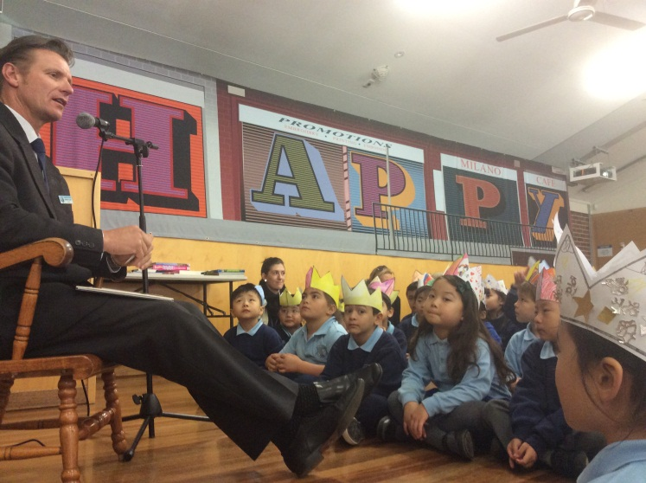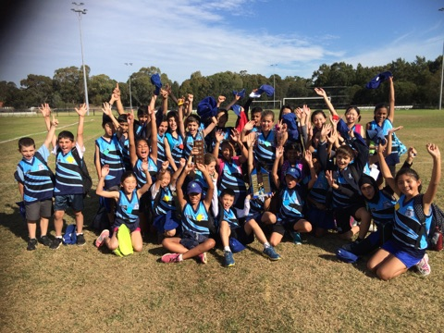
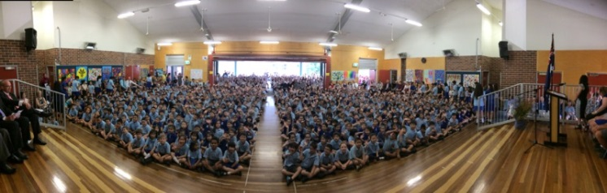
Strategic Direction 3
Environment / Learning Culture - A dynamic school that promotes high expectations, positive values, global awareness and collaborative partnerships.

Purpose
Learning needs to be fun. Positive, happy, learning environments promote collaborative and inclusive learning, a sense of equality, provide different opportunities and leaning experiences for different types of learners, and increase the likelihood that learning will occur. Research shows that successful learning environments result from a three-way partnership between students, staff and parents who are actively engaged in their children’s learning at school. The environment needs to encourage parental involvement, provide opportunities for open ended learning and use technological advances to stimulate imagination and creativity with others.
Overall summary of progress
The K-6 History syllabus and Critical and Creative activities were major professional learning focuses and a sequence of six professional learning meetings and one professional learning day were held with the community of schools (RALBY) to investigate and deepen staff understanding of the History K-10 syllabus. To accommodate this, aspects of projects were postponed until 2016/17.
Average parent participation at P and C Association meetings during 2015 was 15 attendees, ensuring a quorum at every meeting and all positions filled. All P and C events were supported by the community.
Parent workshops, facilitated by the community language team, were held each week in Term 3 to explain current pedagogy and best practice in Literacy teaching and learning. Attendance average was 25 participants, an increase of 50% on previous years.
Nine consecutive 2016 Kindergarten Orientation sessions for parents and students were conducted by the early stage 1 team, with the support of the community language team, P and C Association and learning support team. Attendance average was 85 families represented at each session and 98% of all families attended more than one session.
97.5% of students remained “green” (did not require any behaviour interventions) in 2015. 54 students achieved eligibility to attend platinum level excursions.
As a result of two staff members participating in User Interface Testing (UAT) for LMBR software, all teaching staff were able to access electronic roll marking and student management software (Agent5) successfully on Apple computers/devices.
Progress towards achieving improvement measures |  | Resources (annual)
Improvement measure  (to be achieved over 3 years) | Progress achieved this year | <$>
Increase of parents working in classrooms and attending school events. | Increased parent and community engagement in student learning identified through attendance at workshops, surveys and data. | $400 (Casual day)
Strengthened wider educational community connections to enhance staff and student learning. | Increased evidence of teacher contributions to improving the public education system beyond the classroom | $0
Sustained and increased high levels of staff, student, parent and community engagement. | Sustained high levels of student engagement and learning evident, directly resulting from the newly created learning centres.  All students articulate consistent behaviour and learning expectations K-6. | $0
Enhanced school practices in Wellbeing. | Student voice prevalent in a variety of roles such as SRC, Prefects, House Captains, Library Monitors, School parliament and the Leadership Training Program in school and externally.  *Review and implementation of Student Wellbeing and Student Leadership policies.  *Full implementation of Lifeskills and Live, Life Well school action plan. | Approx $2000
Next steps
2015 AEDC data shows a much higher increase of students entering Kindergarten in the At Risk and Vulnerable categories since 2009 for: physical health and wellbeing (17%); Social Competence (10%); Emotional maturity (12%); and Language and cognitive skills (13%). The school community will work together to maintain and enhance supportive learning environment by:
- Timetabling regular committee meetings to ensure achievement of critical milestones
- Providing professional learning about learning centres and how to ensure best practice to engage students in syllabus outcomes based critical thinking and creativity;
- Identifying some best practices of 21st Century learning to trial in the learning centres with new technology and exploring how we can achieve this in every classroom.
- Supporting all EAL/D students using English language proficiency funding to provide an additional class in 2016;
- Reviewing technology allocation amongst stage and support teams.
- Ensuring whole school consistency by reviewing the student welfare policy and playground supervision;
- Review Teaching and Learning Programs policy.
- Providing regular parent workshops about syllabus documents, best classroom practice and nutrition so parents can support their children from home.
- Commitment to PBL by all staff with enhanced PBL knowledge;
- Reviewing PBL lessons to ensure consistency with current PBL matrix and trialling restorative practices. Our success will be evidenced by shared student data, trends and detention rates, the number of students who understand and articulate PBL expectations, and TTFM data;
- Investigating activities for students during Break 1 and Break 2 and transitions, eg: music bells, cool down spaces;
- Continued participation in Lifeskills, Dance2bfit;
- Sharing school planning with the school community and inviting community members to participate in school leadership committees to provide input;
- Participation in the Tell Them From Me survey by students, teachers and parents; and
- Continuing to celebrate our achievements with students and the whole school community.

Next Steps

Key initiatives and other school focus areas
Key initiatives (annual) | Impact achieved this year | Resources (annual)
Aboriginal background funding | All Aboriginal students have a personalised learning plan (PLP) and are making progress across the literacy and numeracy continuums.  Cultural significance is included in all PLPs. | $3283
English language proficiency funding | The EALD team work with class teachers to collect accurate information as to student progress along the continuum and planning for future teaching.  Please refer to the Multicultural Report in this report. | $542705 (Staffing – 5.4 EAL/D teachers)  $303368 (Staffing – CL teachers)
Targeted students support for refugees and new arrivals | The EALD teacher works with newly arrived students in a small group program to build their cognitive academic language proficiency and increase interactions. | $48802 (Flexible)
Socio-economic funding | Refer to Strategic Direction 2 – Staff Learning | $42144
Low level adjustment for disability funding | All students requiring adjustments and learning support are catered for within class programs and other whole school strategies with individualised learning plans. The Learning Support Team meets weekly to ensure all students are effectively supported in their learning. | $524161 (Staffing – Spec Ed)  $221282 (Staffing – L&ST)  $57772 (Integration funding)
Support for beginning teachers | A beginning teacher was supported by the provision of ongoing feedback through an hour of mentoring with a supervisor each week plus a reduced teaching load through additional classroom release for programming and preparation. The beginning teacher participated in mentoring from colleagues through one day each term with colleagues in collaborative planning processes as well as weekly stage meetings, committee meetings and fortnightly school professional learning workshops. | $14562

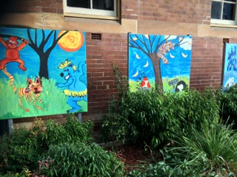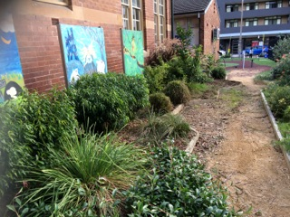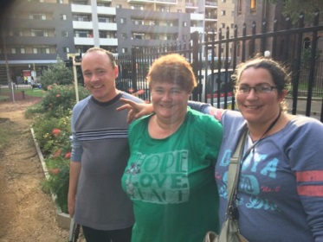

Mandatory and optional reporting requirements

Student information
It is a requirement that the reporting of information for all students be consistent with privacy and personal information policies.

Student enrolment profile
Gender | 2010 | 2011 | 2012 | 2013 | 2014 | 2015
Male | 305 | 295 | 295 | 300 | 316 | 323
Female | 268 | 254 | 258 | 278 | 319 | 325

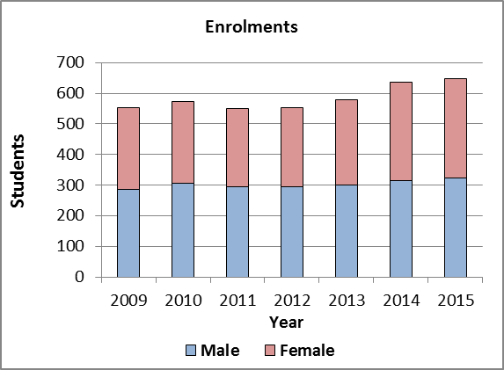

Student attendance profile
 | Year | 2011 | 2012 | 2013 | 2014 | 2015
School | K | 93.2 | 95.0 | 96.3 | 95.9 | 95.4
 | 1 | 96.4 | 94.3 | 95.6 | 96.4 | 94.5
 | 2 | 95.5 | 95.7 | 95.8 | 96.7 | 96.8
 | 3 | 96.3 | 95.2 | 97.8 | 95.8 | 95.5
 | 4 | 95.9 | 95.5 | 97.0 | 97.1 | 96.2
 | 5 | 96.3 | 95.0 | 96.1 | 97.7 | 96.2
 | 6 | 94.8 | 95.0 | 95.3 | 96.5 | 96.6
 | Total | 95.5 | 95.1 | 96.3 | 96.6 | 95.9
State DoE | K | 94.7 | 94.3 | 95.0 | 95.2 | 94.4
 | 1 | 94.2 | 93.9 | 94.5 | 94.7 | 93.8
 | 2 | 94.2 | 94.2 | 94.7 | 94.9 | 94.0
 | 3 | 94.4 | 94.4 | 94.8 | 95.0 | 94.1
 | 4 | 94.3 | 94.3 | 94.7 | 94.9 | 94.0
 | 5 | 94.2 | 94.2 | 94.5 | 94.8 | 94.0
 | 6 | 93.8 | 93.8 | 94.1 | 94.2 | 93.5
 | Total | 94.3 | 94.2 | 94.7 | 94.8 | 94.0
School attendance (95.9% in 2015) is slightly down on the previous 2 years due to the Department’s change in Attendance Policy, but we still exceed regional and state averages. As Lidcombe P.S. has a warm, enjoyable and safe atmosphere we are confident that our attendance rates will maintain its rating of 95% and over.
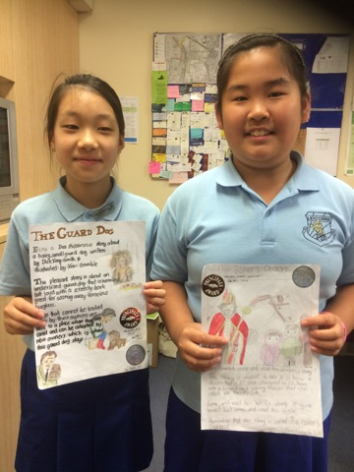
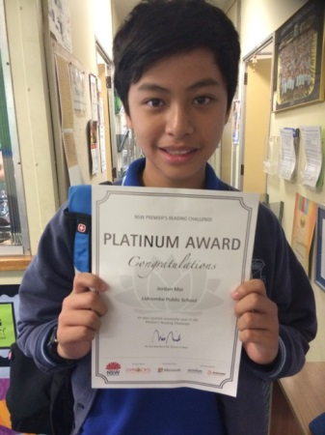

Management of non-attendance
In consultation with the Home School Liaison Officer, Lidcombe Public School implements the NSW Department of Education and Training School Attendance Policy to manage non-attendance. The Learning Support Team proactively supports class teachers in monitoring student attendance through regular checking of class attendance rolls and liaising with the executive accountable for each stage of students. Daily attendance is also encouraged through the school’s merit award system and open, transparent communication with the school community.

Class Sizes
Primary class sizes are included in the annual school report in order to provide parents with as much local information as possible. The following table shows our class sizes as reported at the 2015 Class Size Audit conducted on Monday 19 March 2015.
 | Roll class | Year | Total in class |  | Total per year
1 | K BLUE | K | 20 |  | 20
2 | K ORANGE | K | 20 |  | 20
3 | K PURPLE | K | 20 |  | 20
4 | K RED | K | 21 |  | 21
5 | K YELLOW | K | 21 |  | 21
6 | 1 ACACIA | 1 | 21 |  | 21
7 | 1 EUCALYPTUS | 1 | 20 |  | 20
8 | 1 GREVILLEA | 1 | 19 |  | 19
9 | 1 WARATAH | 1 | 20 |  | 20
10 | 2 BOTTLEBRUSH | 2 | 21 |  | 21
11 | 2 FIREWHEEL | 2 | 21 |  | 21
12 | 2 LILLI-PILLI | 2 | 23 |  | 23
13 | 2 MELALEUCA | 2 | 23 |  | 23
14 | 1/2 BANKSIA | 1 | 8 |  | 22
 |  | 2 | 14 |  | 22
15 | 3/4 BASS | 3 | 18 |  | 28
 |  | 4 | 10 |  | 28
16 | 3/4 COOK | 3 | 18 |  | 28
 |  | 4 | 10 |  | 28
17 | 3/4 FLINDERS | 3 | 18 |  | 31
 |  | 4 | 13 |  | 31
18 | 3/4 LAWSON | 3 | 17 |  | 29
 |  | 4 | 12 |  | 29
19 | 3/4 STURT | 3 | 18 |  | 29
 |  | 4 | 11 |  | 29
20 | 4/5 GOOLAGONG | 4 | 8 |  | 29
 |  | 5 | 21 |  | 29
21 | 5/6 BENNELONG | 5 | 13 |  | 30
 |  | 6 | 17 |  | 30
22 | 5/6 FREEMAN | 5 | 12 |  | 30
 |  | 6 | 18 |  | 30
23 | 5/6 NAMATJIRA | 5 | 13 |  | 30
 |  | 6 | 17 |  | 30
24 | 5/6 TRUGANINI | 5 | 11 |  | 29
 |  | 6 | 18 |  | 29
25 | 5/6 YUNUPINGU | 5 | 13 |  | 30
 |  | 6 | 17 |  | 30
We also had 15 students (in years 3 to 6) in 3/6K, 8 students (years 1 to 6) in 1/6S and 7 students (years K to 4) in K/4J. These were classes in our special education unit.

Structure of Classes
A variety of criteria is used to form classes at Lidcombe Public School. Please note, these criteria are not in order of importance.
- Friendship – students who need support from a close friend.
- Friendship – students who are too friendly and are best separated to ensure productive work practices.
- Behaviour Problems – students who are best separated.
- Learning Difficulties – students who are experiencing difficulties are spread between available classes so specialist support staff can most effectively meet their needs.
- Personalities – in some special cases the personalities of both the students and teachers are considered before a decision is made regarding the placement of a student.
- Gender Balance – where possible a balance of boys and girls is maintained in each class.
- Siblings – where siblings are one grade apart, where possible, they are not placed in multi-age classes (composite) where they will be sharing the same friendship groups.
As well as the above criteria, all classes have been formed to be as academically balanced as possible.

Workforce information
Reporting of information for all staff must be consistent with privacy and personal information policies.

Workforce composition
Position | Number
Principal | 1.0
Deputy Principal(s) | 1.0
Assistant Principal(s) | 4.0
Assistant Principal(s) Special Education | 1.0
Classroom Teachers | 21.0
Teacher of Mild Intellectual Disabilities | 2.0
Teacher of Reading Recovery | 0.92
Learning and Support Teacher | 1.7
Teacher Librarian | 1.2
Teacher of Community Languages | 3.0
Teacher of ESL | 5.4
Counsellor | 1.0
School Administrative & Support Staff | 7.062
Community Engagement Officer | 1.0
Part Time / RFF allocation | 2.496
Total | 54.768

The National Education Agreement requires schools to report on Indigenous composition of their workforce, of which we have two (2) members of staff of Aboriginal descent.

Teacher qualifications
All teaching staff meet the professional requirements for teaching in NSW public schools.
Qualifications | % of staff
Degree or Diploma | 100
Postgraduate | 78
NSW Instit. of Teachers Accreditation | 72

Beginning Teachers
Schools are required to report on how government funding under Great Teaching, Inspired Learning (GTIL) has been used to support beginning teachers adjust to their new roles in NSW public schools.
In 2015, Lidcombe Public School had one permanent beginning teacher who had over 3 years experience in the classroom. Under the GTIL model, the teacher received funding to assist in the new teacher’s induction, professional development and achievement of accreditation at the level of Proficient teacher. An experienced teacher colleague provided mentoring support to the seven temporary teachers within their first 5 years of teaching.
Permanent beginning teachers utilised their additional release time in a variety of ways including:
- observing other teachers' lessons
- engaging in professional discussion and personal reflection
- assessing and evaluating student work
- preparing lessons and resources
- undertaking individualised programs of professional learning
- compiling evidence to achieve and maintain mandatory accreditation
- team teaching; and
- structured feedback meetings with supervisors and mentors.

Significant professional learning programs in which beginning teachers have participated and programs which have built the capacity of new scheme teachers
- Accreditation at Proficient Teacher Level course
- NSW Teacher Mentor Early Career Teacher Network
- Disability Standards for Education online course
- Early Career Teachers conference
- Behaviour Management for Beginning Teachers
- Language, Learning and Literacy (L3 Stage 1), Classroom Teacher Professional Learning
- In-school Induction Program including school routines, programming policy and requirements, class- room management and welfare policy, accreditation, communication with parents, Performance and Development Framework, assessment strategies, report writing and Quality Teaching Framework .

Professional learning and teacher accreditation
Our teachers and support staff participated in a range of learning activities during the year. Emphasis was placed on development at the stage or team level, with fortnightly meetings and team planning time each term. School Development Days focused on school priorities as defined in the School Plan 2015-2017. Our Teacher Professional Learning (TPL) budget was a little over $30000 and of course, we added to this to ensure our students were experiencing the best trained teachers education had to offer. Additional TPL funds were used for Best Start, the continuation of a Quality Teaching Project - L3, PLAN training including the use of Literacy and Numeracy Continuums and the engagement of a specialised teacher for students requiring support in Literacy and Numeracy. Also, additional TPL budget was allocated for Australian Curriculum planning and implementation.
Including both permanent and temporary teachers, 46% of staff are classed as New Scheme teachers either working towards Board of Studies Teaching and Education Standards (BOSTES) accreditation or maintaining accreditation at Proficient. No teachers are currently seeking or maintaining voluntary accreditation at Highly Accomplished or Lead.
To build the capacity of staff to achieve key priorities, Teacher Professional Learning in 2015 included:
New NSW History Syllabus
Curriculum leaders and committee members participated in History training inservices across the RALBY network with HSIE consultant, Anne Southwell. These sessions highlighted changes within the NSW K-10 History Syllabus and provided teaching ideas for implementing an inquiry based teaching model. Each session explored different aspects of each syllabus for teachers to deepen their knowledge of new content and pedagogy. All staff, under the leadership of curriculum teams, participated in a range of professional learning courses to support the implementation of these new curriculum. Learning modules explored planning, programming, teaching and assessment practices for the new NSW K-10 History Syllabus.
Literacy
One Kindergarten teacher received ongoing professional learning in L3; a literacy program for Kindergarten teachers in which explicit teaching of reading and writing skills for young children takes place in ‘micro’ groups of 3 or 4 students, whilst 12 teachers received training in L3 Stage 1, building on from what students learnt with L3 in Kindergarten into Year 1 and 2. An assistant principal became a head trainer in L3 Stage 1.

Sport and Health
Coaching courses were undertaken by teachers in cross country, football and athletics. Two teachers were involved in Live Life Well @ School training.

Leadership Development
Assistant Principals (5), Deputy Principal and Principal conferences were attended by executive staff. RALBY Community of Schools was formed to support leadership development across 5 local primary schools.

Student Welfare
Teachers were trained in Child Protection updates, WHS procedures and CPR, anaphylaxis and e-Emergency Care re-training. Targeted professional learning was undertaken by classroom and support teachers and SLSOs in Understanding Autism Spectrum Disorders and Understanding Dyslexia and Significant Learning Difficulties.

Financial information
Financial summary for 229 (SAP) schools
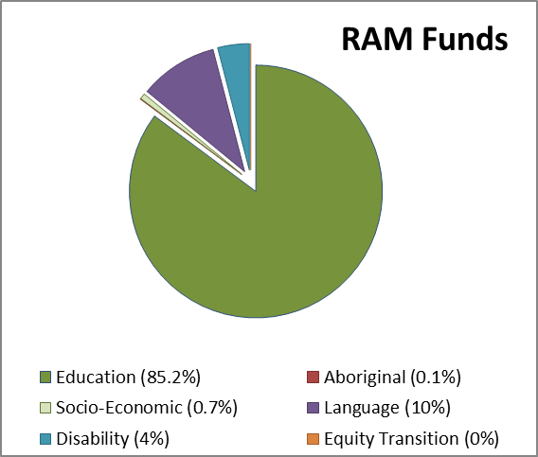
Component |  | RAM
Base |  | 3,940,842
Location |  | -
Other Base |  | 3,940,842
Equity |  | 875,881
Aboriginal |  | 3,283
Socio-Economic |  | 42,144
Language |  | 591,507
Disability |  | 238,947
Equity Transition |  | -
Targeted Total |  | 600,002
Other Total |  | 498,993
Total |  | 5,915,718

2015 Actual ($)
Opening Balance |  |  | 467,142
Revenue |  |  | 6,222,291
 | Appropriation |  | 6,018,119
 | Sale of Goods and Services |  | 15,137
 | Grants and Contributions |  | 179,674
 | Investment Income |  | 9,361
 | Gain and loss |  | -
 | Other Revenue |  | -
Expenses |  |  | (5,965,637)
 | Recurrent Expenses
 | Employee Related |  | (5,531,342)
 | Operating Expenses |  | (433,852)
 | Capital Expenses
 | Employee Related |  | (443)
 | Operating Expenses |  | -
Surplus/Deficit for the Year |  |  | 256,654
Balance Carried Forward |  |  | 723,795

School performance
School-based assessment
NAPLAN
In the National Assessment Program, the results across the Years 3, 5, 7 and 9 literacy and numeracy assessments are reported on a scale from Band 1 to Band 10. The achievement scale represents increasing levels of skills and understandings demonstrated in these assessments.
NAPLAN - Literacy (including Reading, Writing, Spelling and Grammar and Punctuation)

Student NAPLAN Performance Year 3 Literacy
Reading
- Performance is 31.5 points below state average and is 8.1 points above 2014 results.
- 87% students achieved above minimum standard
- 14.8% students in Bands 1 and 2 (10% in state)
- 34.1% students in Bands 5 and 6 (50% in state)
Areas of strength- Directly locate- locates directly stated information in a simple factual text, identifies a comparison in a simple factual text, locates information in a short narrative, locates directly stated information in a short narrative, matches text and images in selected texts
Inference- interprets information in a simple factual text, interprets information in a short narrative, infers the agent for an action in a short narrative, infers the reference for a response in a short narrative, identifies the effect of figurative language in a narrative.
Key Ideas- identifies the complication in a folktale.
Areas for further development- Directly locate- locates information in a poster, locates a fact in a poster, identifies the audience of a poster, connects common information across selected texts, identifies directly stated information in a narrative. Main idea- interprets the overall tone of one part of a text, identifies the purpose of a folktale. Genre- identifies the text type of a folktale. Inference-identifies the reference for a pronoun in a narrative. Narrative- identifies the narrative purpose of two paragraphs in a narrative.

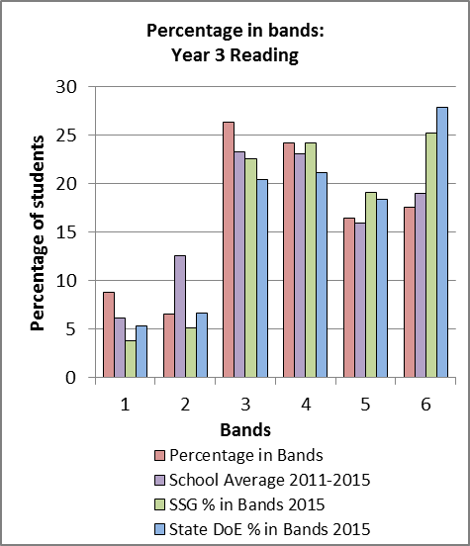

Writing
- Performance is 13.9 points below state average and is 21.1 points above 2014
- 93% of students performing above minimum standard (State is 96%)
- 12% students in Bands 1 and 2 (6% in the state)
- 53% students in Bands 5 and 6 (54% in state)
Areas of strength- Audience - attempts simple written comment, awareness of intended audience
Text structure- writes elementary persuasive text, awareness of persuasive text structure, uses simple reason to expand on ideas,
Vocabulary- basic persuasive text vocabulary,
Cohesion- use of cohesive links in text to combine clauses
Sentence structure- use of simple sentence structure
Punctuation- beginning to use capital letters and full stops
Spelling - writes words using blends, letter combination, long vowel sounds, double consonants, double vowels
Areas for further development- Audience- identifies audience and adjusts writing, explores options to influence the reader, uses features and structures to engage and persuade the audience
Text structure- structures persuasive text to engage and convince the reader,
Ideas- develops language choices and devices and elaborates on ideas to influenced reader by precise and sustained language choices.
Persuasive devices- effective but not sustained use of persuasive devices to sustain the writers position
Vocabulary- use of effective authoritative and technical words and modality to convince the reader, precise and sustained language choices,
Cohesion- variety of conjunctions and connections
Paragraphing- constructs parargraphs
Sentence structure- compound and complex sentences, write consistently effective, controlled and well developed sentences to express precise meaning
Punctuation- correct basic and complex punctuation in writing, uses punctuation to shape meaning and effect
Spelling- accurately spells difficult words and effective vocabulary used to shape meaning.

Spelling
- Performance is 6.1 points below state average and is 15.6 points below 2014
- 86% of students performing above minimum standard (State is 96%)
- 21% students in Bands 1 and 2 (14% in the state)
- 52% students in Bands 5 and 6 (47% in state)
Areas of strength- long vowel, one syllable word, one syllable homophone, diagraph-oy, short vowel-)
1 or 2 syllable word, 3 syllable word, x- as in exactly, double letters, final consonant pattern –cts (insects)
Areas for further development - One syllable word with fricative- face, two-syllable word with the medial long vowel -i. (spider), two-syllable word with the medial digraph – ck, one-syllable word with the final consonant pattern –dge, two sounds: correctly spells a three-syllable word with the letter - x at the syllable juncture, two-syllable word with the suffix – ist, one-syllable word with the final long vowel pattern - alk two-syllable word with the suffix – es, identifies an error then correctly spells a two-syllable word with the suffix – ful, three-syllable word with the medial elided - e. (nursery), two-syllable word with the long vowel pattern - eeze. (squeeze), two-syllable word with the medial letter pattern – gu (disguised).

Grammar and punctuation
- Performance is 35.3 points below state average and is 4.3 points below 2014
- 87% of students performing above minimum standard (State is 94%)
- 21% students in Bands 1 and 2 (11% in the state)
- 35% students in Bands 5 and 6 (52% in state)
Areas of strength- prepositions-identifies the correct preposition to complete a complex sentence, adjective- identifies the adjective to complete a simple or compound sentence, superlative adjective- identifies the correct superlative form of an adjective to complete a complex sentence, question mark- identifies the simple sentence requiring a question mark, speech mark- identifies the correct punctuation of direct speech in a simple sentence, identifies the correct boundary punctuation between a complex and a simple sentence
Areas for further development-
Determiner - identifies the correct determiner to complete a simple sentence, tense- identifies the correctly structured simple sentence, irregular verb- identifies the correct use of an irregular verb in a simple sentence, pronoun- identifies the correct use of a possessive pronoun in a simple sentence, singular/plural- identifies the noun which has the same singular and plural forms, sentence- identifies the sentence which correctly combines all the information in a table, capital letters- identifies the correct punctuation of proper nouns in a simple sentence, article- identifies the sentence with the correct use of an indefinite article.

Student NAPLAN Performance Year 5 Literacy
Reading
- Performance shows an upward trend of 6.1 scaled points compared to 2014 (16.9% below State)
- 100% of students achieved some growth against their Year 3 results.
- 89.2% students achieved above minimum standard.
- 25% students in Bands 3 and 4 (19.6% in state), this is an increase of 5.4% on 2014
- 36.3% students in Bands 7 and 8 (37.5% in state), this is an increase of 16.8% on 2014
- Areas of strength: locating directly stated information in an information text, identifying the purpose of a map, matching text and symbol in a multi-text.
- Areas for further development: inferential comprehension, interpreting and identifying details, and changes in character’s attitudes.
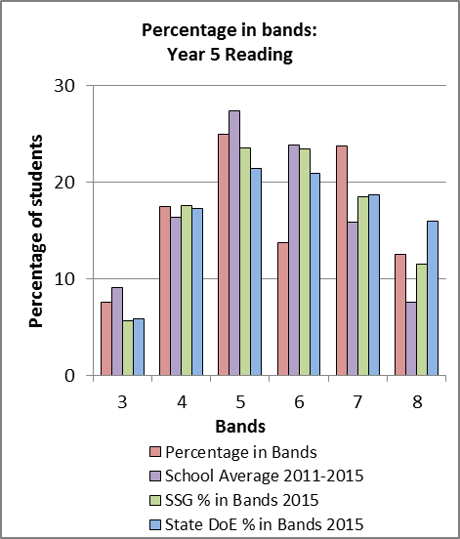

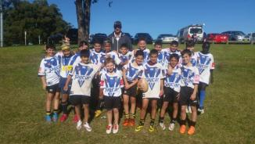
Writing
- Performance shows a slight downward trend of 0.7 scaled points compared to 2014 (10.6 below State)
- 93% of students achieved some growth against their Year 3 results.
- 85.1% of students performing above minimum standard.
- 22.2% students in Bands 3 and 4 (14.5% in
state) this is an increase of 6.4% on 2014.
- 19.7% students in Bands 7 and 8 (21.4% in state) this is an increase of 5.1% on 2014
- Areas of strength: writes elementary persuasive texts, using simple reason to expand on one or a few simple ideas to engage and persuade the reader, using simple vocabulary, using simple conjunctions and using simple punctuation.
- Areas for further development: more complex writing using more sophisticated ideas and vocabulary.

Spelling
- Performance shows a downward trend of 21.8 scaled points compared to 2014 (on par with State)
- 96% of students achieved some growth against their Year 3 results.
- 86.9% of students performing above minimum standard.
- 18.5% of students in Bands 3 and 4 (14.9% in state), this is an increase of 8.8% on 2014.
- 47% students in Bands 7 and 8 (39.9% in state), this is a decrease of 12.8% on 2014.
- Areas of strength: correctly spells two-syllable words with a long vowel ending – y,
- Areas for further development: revise spelling program for this cohort of students.

Grammar and Punctuation
- Performance shows a downward trend of 18.1 scaled points compared to 2014 (below State by 16 scaled points)
- 93% of students achieved some growth against their Year 3 results.
- 79.8% of students performing above minimum standard
- 25.9% students in bands 3 and 4 (16.5% in state), this is an increase of 7.6% on 2014.
- 41.8% students in Bands 7 and 8 (38.7% in state), this is a decrease of 5.8% on 2014.
- Areas of strength: identifies the adjective to complete a simple sentence.
- Areas for further development: correct punctuation, identifying adverbs and correct main clause.

- 37.2% students in Bands 8 and 9 (29.1% in state), this is an increase 6.5% on 2014.
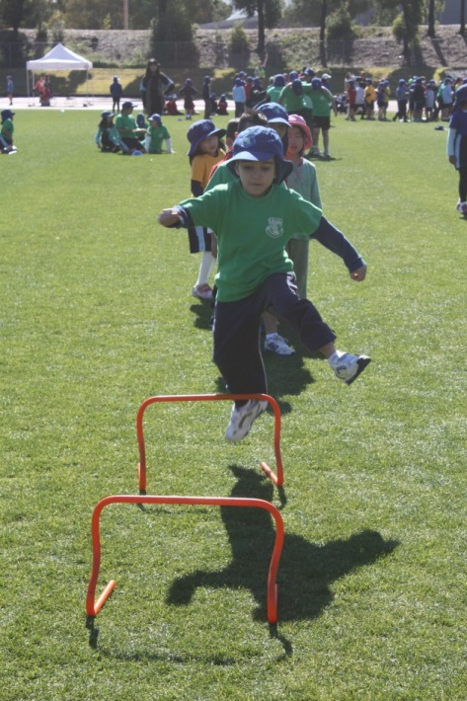
NAPLAN - Numeracy
Student NAPLAN Performance Year 3 Numeracy
Overall Numeracy
- Performance was 29.9 points lower than the state average and is 6.5 points below 2014 results
- 84% of students performing above minimum standards.
- 29.7 % students in Bands 1 and 2. (17% in state)
- 28.6% students in Bands 5 and 6. (38% in state)
Number, Patterns and Algebra
Areas of strength- uses names for operation symbols, continues a simple number pattern, uses place value to determine the largest number. Areas for further development- identifies smallest number in a group identifies order of objects using positional language- (interpret and use), identify midpoint of numbers on a number line, solve a simple division word problem, orders 4 digit numbers.

Data, Measurement, Space and Geometry
Areas of strength- estimates length, identifies the missing 2D shape from a grid, identifies a sphere, faces on a 3D shape.

Areas for further development- identifies objects that are equal in size, spatial awareness of 2D objects, interprets information on a picture graph- calculates difference, reflection of a 2D shape, digital time to words, positional language, word problems- How many more?, reads a scale to determine mass.

Student NAPLAN Performance Year 5 Numeracy
Overall Numeracy
- Performance shows a slight downward trend of 2.4 scaled points compared to 2014, and 3.8 scaled points above state.
- 100% of students achieved some growth against their Year 3 results.
- 89.2% of students performing above minimum standard.
- 28.7% students in Bands 3 and 4 (18.3% in state), this is an increase of 6.7% on 2014.
- 37.6% students in Bands 7 and 8 (30.7% in state), this is a decrease of 3.9% on 2014.
- Areas of strength: division-money / calculate
unit costs, calculates the sum of three
tallies, multiplication
- Areas for further development: whole numbers – identifying numbers negative and positive on a number line.

Student NAPLAN Performance Year 7 Reading
- School trend shows a downward trend of 6 scaled points compared to 2014.
- 20.9% students in Bands 4 and 5 (16.1% in state), this is an increase of 2.2% on 2014.
- 28.3% students in Bands 8 and 9 (31.8% in state), this is an increase of 3% on 2014.

Student NAPLAN Performance Year 7 Numeracy
- School trend shows a slight downward trend of 1.4 scaled points compared to 2014.
- 15.1% students in Bands 4 and 5 (17.8% in state), this is a decrease of 4.9% on 2014.

Parent/caregiver, student, teacher satisfaction
Each year schools are required to seek the opinions of parents, students and teachers about the school.
Their responses are presented below.
The school and P and C Association developed a school satisfaction survey that was sent to all school families through the school newsletter. 52 families completed the survey:
- All respondents agreed that the students are the school’s main concern and student achievement is recognised throughout the school. Families are kept informed by the school newsletter. The school responds to enquiries and requests in a prompt and friendly manner.
- 100% of respondents agreed that the school maintains a focus on literacy and numeracy and the annual school report provides important information about the school.
- 100% of respondents agreed that the school is an attractive and well-resourced school. The school teaches and promotes core values. Parents value the school website.
- 98% of respondents agreed that the school has supportive welfare programs, promotes its uniform policy and has competent teachers who set high standards. There is good student access to technology programs and resources.
- 96% of the respondents agreed the school is connected to its community and welcomes parental involvement and that the school promotes a healthy lifestyle.
- 94% of respondents agreed that the school offers challenging programs for its students and a wide range of extracurricular programs are offered. The fortnightly newsletter is valued.
- 89% agreed that the student achievements are recognised through the school award system, (SLR’s, Bronze, Silver, Gold and Platinum awards) and that Fair discipline exists within the school.

2015 Staff Survey on Educational Programs

Staff were surveyed for their individual feedback on the school’s teaching and learning programs. 30% of staff completed and returned the online survey.

80% of respondents rated L3 (K-2 Literacy)and Reading Recovery as having the greatest impact on teachers’ teaching and student learning. This was followed closely by the school’s sport and performing arts programs, and TENS (K-2 Numeracy) Teachers supported these choices by stating that these programs feature explicit goals, targeted teaching that reflects students’ needs, ongoing data collection and immediate feedback to the students about their learning.

All of the respondents indicated that Literacy and Numeracy need to be the main focuses for the school over the next two years. Professional learning and performing arts were also advocated by some respondents.

All respondents stated that they were supported by the executive and specialists, and that they ion turn supported the executive. The all supported the in-school professional learning organisation.

Future directions

Continue to empower students with learning strategies, based on explicit learning goals.
Meet regularly to share and reflect on student learning data and refer back to the school plan.
Embed more creative and critical thinking.

Policy requirements
Aboriginal education
NAIDOC Week
NAIDOC stands for National Aborigines and Islanders Day Observance Committee. At Lidcombe Public School we strive to increase awareness in the whole school community of the status and treatment of Indigenous Australians.
NAIDOC Week is held across Australia in the first full week of July. This week falls in the NSW Term 2 school holidays. At Lidcombe Public School, we celebrated NAIDOC Week in early Term 3. We celebrated Aboriginal and Torres Strait Islander history, culture and achievements and recognised the contributions that Indigenous Australians make to our country and our society.
All students participated in exciting cultural activities that included a didgeridoo show and storytelling, artefacts, weaponry, bush survival, aboriginal song and dance, aboriginal face painting, interactive aboriginal art on canvas and boomerang throwing.
Aboriginal education is embedded into the curriculum as we support the students’ needs to be educated about Aboriginal Australia. The inclusion of the cross curriculum priorities in all Key Learning Areas allows students in K-6 to engage in studies of Aboriginal and Torres Strait Islander histories and cultures. A major focus of the development of English units using the new NSW English K-6 Syllabus encompassed the concepts of Country and Place, People, Culture and Identity. In their study of English, students had the opportunity to engage with texts that give them experience of the beliefs and value systems of Aboriginal and Torres Strait Islander peoples.
Acknowledgment of Country is an important part of the school’s assemblies and events and is helping create a wider awareness in the community of Indigenous history and current issues.
All Indigenous students, (<1% of enrolment), have personalised learning plans to track their success and to target aspects of their learning needing further development.
Recommendations for 2016
NAIDOC Week will be recognised in 2016 and the Engagement committee has suggested that an Indigenous fundraiser ‘Book Swap’, held in term 4 this year be incorporated into NAIDOC Week in 2016.
Multicultural Education and Anti-racism
Target:
Improved student outcomes in Literacy with an emphasis on development of quality pedagogy.
Evidence of Progress towards target:
- Withdrawal intensive English language support to newly arrived students throughout the school not less than 3 hours per week.
- Variety of standardised testing methods such as Running Records and observation survey used by EAL/D teachers to track progress of their NAP students and to inform planning.
- All NAP students are placed at their appropriate level on the EAL/D continuum and monitored for their progress.
- Ongoing professional discussions with main stream teachers regarding the progress and learning needs of NAP students.
- Team teaching during Guided Reading lessons to teach comprehension strategies explicitly (all stages)
- Provided ongoing support to the mainstream teachers on understanding how to use the EAL/D continuum.
- Team teaching in Special Education unit by Early Stage 1, Stage 2 and Stage 3 EAL/ D teachers to develop literacy skills among the students as well as sharing EAL/D pedagogy with the teachers.
- Participated in ongoing professional dialogue through sharing of resources and professional development articles during EAL/D meetings resulting in improved pedagogical skills and an understanding of appropriate resources.
- All EAL/D teachers actively participated in whole school professional development on the New History Syllabus document and have supported classroom teachers in planning teaching units to trial in classrooms.
- Small group teaching in collaboration with the main stream teachers in Early stage 1 to develop language of mathematics and oral language skills as part of the action plan of the Early Stage 1 ESL teacher.
- Stage 1 teachers were in-serviced on the EAL/D learning progression and supported in catering for New Arrival and LBOTE students within the classroom.
- Collaborative teaching with a focus on reading and writing combining L3 strategies with EAL/D pedagogy in Stage 1.
- Inclusion of Discovery Learning activities into L3 Learning Centres to promote oral interaction and increase vocabulary in Stage 1
- Introducing ‘Digital and Multimodal Text’ to develop visual literacy in Stage 2.
- Organisation of maths groups in Stage 3 involving collaborative planning and teaching by classroom teachers and EAL/D teacher to develop mathematical language and problem solving skills.
- Supported mainstream teachers in Stage 2 and Stage3 in preparing students for the Public Speaking competition to develop confidence in oral language and public speaking.
- CL teachers withdrawing targeted students to provide support in the ‘comprehension’ aspect of the literacy continuum, in both the students’ first language and English.​
- Initial withdrawal time with the Chinese community language teacher for new arrival Chinese students to develop basic communication skills and to conduct basic assessments. (This has helped early identification of learning difficulties)
- Using the support of community language teachers (Korean and Chinese) to communicate with the parents of NAP and other EAL/D students.

Effectiveness of key strategies implemented to achieve the target:
- Combining L3 strategies with EAL/D strategies during literacy lessons has proven to be successful in improving the outcomes for all students.
- Team teaching during reading lessons has led to positive outcomes resulting in continuous professional dialogue between main stream teachers and EAL/D teachers regarding how best to meet the learning needs of students.
- Emerging and Developing EAL/D students who had difficulties in advanced comprehension strategies such as inferencing and evaluating have benefited from additional in-class support provided by the EAL/D teachers.
- Early stage 1 students have shown increased participation in speaking as a result of the small group lessons conducted by the EAL/D teacher.
- EAL/D teachers are confident in using the new EAL/D learning continuum and taking a leadership role in introducing and implementing the continuum.

Reasons for maintaining or revising targets for next year.
- Current strategies such as collaborative planning, targeted support, withdrawal NAP groups, team teaching and ongoing discussions on student achievement and sharing of EAL/D pedagogy have proven successful. Therefore it is important to continue using these strategies to maintain the progress that we have achieved in the past year.

Targets for next year:
- Continue placing New Arrival students on the EAL/D continuum throughout the school and use this continuum to determine future directions of teaching /learning.
- Continue using ACARA – EAL/D student work samples to inform CTJ together with National exemplars when assessing EAL/D students.
- Provide professional development to all new staff on understanding EAL/D progression during stage meeting times.
- Continue to work collaboratively with mainstream teachers and maintain an active role in using effective EAL/D strategies.
- Continue supporting Special Education teachers to implement EAL/D strategies in their classrooms.
- Support in creating and teaching differentiated learning programs to improve learning opportunities and outcomes for all students both in literacy and numeracy.
- Stage 2 and Stage 3 EAL/D teachers to work together with Stage AP’s in analysing NAPLAN data to identify major areas of needs for Beginning, Emerging and Developing Phase EAL/D students.
- Stage 1 EAL/D teacher to use NAPLAN analyses to find out the areas of needs and plan together with the stage 1 teachers to develop the skills needed for EAL/D students to be successful in both literacy and numeracy.
- Use bi-lingual testing to initially assess New Arrival students who have little or no competency in English language with the support of the community language teachers.

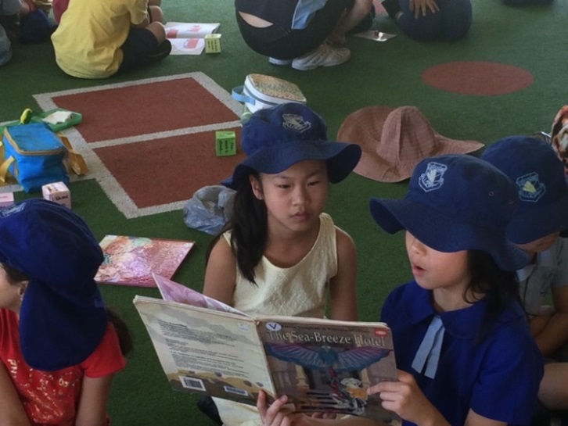

Other school programs
Achievements in the arts and sport.
Arts:
- All students performed in the school’s annual community celebration. The 2015 theme was “Heroes”. Performance items included acting, dancing, singing and an IT response through class movies.
- 53 Stage 1 students participated in a singing group organised by Ms pant as a lunchtime activity. The singing group were invited to perform at the Dooley’s Christmas Fair at Lidcombe, Auburn Centre Christmas Tree opening, opening of the new Lidcombe shopping centre at Woolworths and Kmart, Kmart Wishing tree appeal and also 23 students performed in Granville schools “Our Spectacular” at the Opera House.
- 22 students from Stages 2 and 3 were chosen to be in the Senior Choir. These students also participated in the Granville schools “Our Spectacular”. The Senior Choir met twice a week and practised a variety of songs with Mrs Kim and Ms Yang. They were invited to perform at several events in the local community.
- 21 Stage 2 and 3 students participated in the schools dance group lead by Miss Clift. Dancers and the Junior Choir were selected to perform in Grandville schools “Our Spectacular” at the Opera House in a combined song and dance routine (54 students in total).

Sport:
Early Stage 1
- In 2015, Kindergarten participated weekly in 45-minute sport sessions in addition to regular class fitness activities, which were implemented throughout the week.
- During sport lessons, Kindergarten focused on developing whole body and fundamental movement skills such as: throwing, catching and kicking a ball, balancing, jumping, hopping, skipping and running. These activities assisted students in developing good basic skills and co-ordination.
- All sports activities were selected from the Board of Studies, Personal Development, Health and Physical Education K-6, Outcomes.
- In addition, students enthusiastically participated in the ‘Premier’s Sporting Challenge’ with their teachers’ encouragement.
- In Term 2, Kindergarten participated in the Dance2bFit program. This program provided the opportunity for students to observe and repeat sequences of whole body movements in dance through an assortment of music and energetic dance styles.
- In Term 3, Kindergarten was given the opportunity to participate in the LifeSkills program. The program aimed to increase student concentration, relaxation, balance and posture. It also enabled students to recognise the feelings of others and to work co-operatively to achieve a goal.

Stage 1
- During 2015, Stage 1 sport occurred once a week for a period of 45minutes. Regular class fitness sessions were also implemented throughout each week.
- During weekly sport Fundamental Movement Skills were explicitly taught with a focus on games and skills.
- In Term 2 students had the opportunity to participate in Life Skills lessons weekly. The 10 week program focused on teaching students and teachers how to Build Resilience, Develop Self Regulation, Increase Self Awareness, Strengthen Problem Solving Skills and Practice Positive Relationship Skills. The fundamental movement programs focus on physical, social, emotional and attention self regulating strategies and skills, developed to systematically cultivate wellbeing, resilience and lifelong learning, providing healthy skills for your students’ physical, social, emotional and mental wellbeing.
- In Term 3, Stage 1 participated in the weekly Dance2bfit program, which is designed to meet the NSW PDHPE syllabus to help students achieve the required Dance outcomes. A new dance was taught each week during these high energy, fun sessions.
- In addition, students participated in the 10 week “Premiers Sporting Challenge’, which engages young people in sport and physical activity and encourages them to lead health, active lifestyles.
- Year 2 students also participated in the school’s ‘Swimming Scheme’ program in Term 4. This is a learn to swim program that develops water confidence and provides students with basic skills in water safety and survival. Students are given the opportunity to attend daily lessons of 45mminutes over 10 consecutive days.

Stage 2 & 3 Sport
An integral part of the K6 curriculum, sport teaches students skills and values whilst providing them with rigorous fitness opportunities to maintain a healthy lifestyle. In 2015:
Lidcombe entered 18 teams in all Primary Schools Sports Association (PSSA) competitions, consisting of 216 players. Lidcombe participated in League Tag, AFL, Cricket, Newcombe Ball, Soccer, Netball, T Ball and Softball.
Of these 18 competitions we were successful in winning 8 premierships. These were Junior Soccer, Senior Girls League Tag, Junior Boys League Tag, Junior Netball, Junior Newcombe Ball, Girls Softball, Junior AFL and Senior AFL.
Lidcombe was the Champion School for the Overall and Percentage Trophy at the Auburn Zone Swimming Carnival. The Champion School at the Auburn Zone Cross Country Carnival overall and on percentage, and the Champion School at the Auburn Zone Athletics Carnival, both overall and for the percentage trophy.
Lidcombe had a total of 111 students represent our school at zone carnivals and 30 at regional carnivals. There were 4 age champions at Auburn Zone Carnivals. Monalisa Soliola was the Age champion for 11 Year Girls Athletics while Edwin Cho, Kapeliele Fusi and Jessica Trang were all Zone Age Champions in Swimming.
Two students represented Auburn Zone, playing in the Auburn Zone Soccer team at the Sydney West Regional trials. One of these students was then selected to represent Sydney West in the NSWPSSA State Soccer Championships. One student also played in the Sydney West Rugby Union team that competed in the NSWPSSA Championships. We also had one student who represented NSW at the National Championships in discuss and shot-put. Lidcombe entered teams in the Soccer, AFL, Netball and Boys and Girls Touch Football State Knockouts.
A student from Lidcombe Public School was also nominated for awards at the Auburn Council’s Sports Stars ceremony.
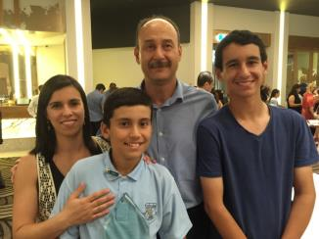
Transition to School Program
The Transition to School program ran during Term 4 beginning with an evening meeting to introduce families to the school and to explain the importance of preparing children for starting school. The main component of the program entailed eight, two hour visits held weekly when parents and prospective students came together and spent time visiting school areas and interacting with teachers and students.
For the first four weeks families stayed together visiting classrooms, the playground, the office and library. Prospective students brought along a fruit snack to share ‘Crunch and Sip’ time with kindergarten students. Each week the visiting children took home a ‘Dilly Bag’ containing an activity they could complete with their families at home.
During the second half of the program visiting children were encouraged to continue the visits independently whilst their parents/carers participated in various workshops that were organised. Workshop topics included preparing for school, enrolment procedures, road safety, healthy eating, attendance, community programs for supporting families, literacy and numeracy programs. Speakers included school staff, Department of Education representatives and representatives from local outside agencies such as an occupational therapist, Family Referral Service and the Cancer Council.
For the second year running the Transition to School program was supported by Connect Child and Family Services which provided a facilitator and funding for additional staffing and materials.
Over the eight weeks of the program 115 children attended. The weekly average attendance was 77 children and 73 children attended between five and eight of the sessions. Both the children and parents were able to make social connections which are still evident in the classrooms and playground.

International Competitions
Each year, students from Years 3 to Year 6 are given the opportunity to participate in the International Competitions and Assessment for Schools (ICAS). The ICAS are independent evaluations of students’ skills and knowledge in key learning areas and provide an insight into students’ understanding.
All students who participated in the assessment received a participation award while students with outstanding achievement were rewarded with Certificates of Merit, Credit, Distinction and High Distinction.
Mathematics
(99 students participated) 8 Distinctions; 20 Credits; 9 Merits; 62 Participation
English
(107 students participated) 3 Distinctions; 18 Credits; 8 Merits; 78 Participation

Eco-Kids
Across the school, there is an emphasis on environmental education and sustainability. The school ran the Eco Kids program, where students from Stage 2 and Stage 3 participated in various environmental and sustainability activities including weeding, planting, watering and worm farming.
The Eco Kids program was held every Tuesday during lunch time.
Students learnt about worm farming and maintained three working worm farms by regularly feeding the worms and collecting the worm wee fertilizer. They held a stall at the school’s Community Celebration Day to sell the worm wee fertilizer. The money raised was used to purchase equipment and resources for our environmental programs.
The worm farm fertilizer was also used for nourishing the native plants surrounding the school as well as the functioning vegetable gardens by the students.
On the National Tree Day, the Eco Kids planted a variety of native plants, such as Grevilleas and Gymea Lilies donated by our local Bunnings store.
The Eco Kids planted vegetables, such as capsicum, tomatoes, beans, carrots and herbs such as, thyme and oregano. The vegetables and herbs were harvested and used by Special Education students in their cooking and life skills program.

Student Welfare Report 2015
Student welfare programs are overseen by the school’s Learning Support Team, in partnership with the Positive Behaviour for Learning (PBL) Team, Student Representative Council (SRC), P & C, and the school staff.

The Engagement Team re-introduced peer-led lunchtime activities to support positive student interactions and physical activity on the playground. In 2015, 97.5% of our students were “Green” (ie: did not require any negative behaviour interventions) and attended Green events. 35 students were referred to the Learning Support Team for additional learning and/or behavioural supports and the school successfully submitted fourteen access requests for special class placements or integration funding support. 54 students achieved eligibility to attend a platinum level excursion in 2015.

Future Directions:
- Review PBL lessons so they reflect the updated expectations matrix;
- Review Playground supervision procedures;
- Review the organisation of the school’s LaST resource and Teaching and Learning Programs policy in line with the school Learning Support Policy, “Every Student Every School,” 21st Century learning and the School Excellence Framework; and
- Continue to celebrate our achievements with students and the community.

